**EXP -9**

**ABOUT VIEWS**

**1.**Create

*CREATE VIEW [Products Above Average Price] AS*

*SELECT ProductName, Price*

*FROM Products*

*WHERE Price > (SELECT AVG(Price) FROM Products);*

*SELECT * FROM [Products Above Average Price];*

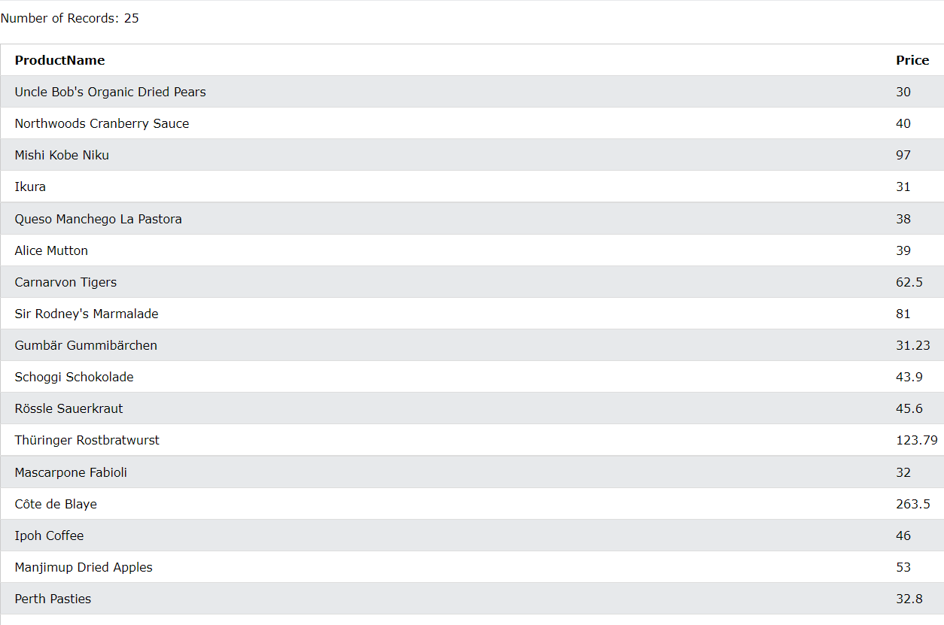

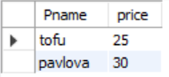

*2.*Update

*CREATE OR REPLACE VIEW [Brazil Customers] AS*

*SELECT CustomerName, ContactName, City*

*FROM Customers*

*WHERE Country = 'Brazil';*

*3.*Drop

*DROP VIEW [Brazil Customers];*